
AMERICAN INTERNATIONAL UNIVERSITY-BANGLADESH
Faculty of Science and Technology
Department of Computer Science
CSC 3215: Web Technologies

Semester: Summer 2025-26 | Group No: 02 |  | Section:L

Group Members:
SL. | Student ID | Name | Role | Signature
1 | 23-52631-2 | ABU SALEH MOHAMMAD JAEEF | Group Leader
2 | 23-52646-2 | MD. NAFIZ IQBAL ROHAN | Member
3 | 23-52648-2 | MD. AL AMIN | Member
4 | 22-49590-3 | MD ASHRAF UL ANAM | Member
Project Title
CampusXP – Smart Campus Opportunity, Club Recruitment & Corporate Drive Platform
Short Description
CampusXP is a centralized, role-authenticated web application engineered specifically for the American International University-Bangladesh (AIUB) academic and co-curricular ecosystem. Developed using a robust Model View Controller (MVC) architectural pattern with procedural MySQLi prepared statements in PHP 8.2 and MySQL InnoDB, CampusXP bridges the critical operational divide between university students, student club executives, corporate industry recruiters, and Office of Student Affairs (OSA) administrators. The platform completely replaces fragmented social media notices, unindexed Google Forms, and manual physical paper requisition slips with an integrated digital workflow featuring a live Opportunity Radar, a permanent Statement of Purpose (SOP) Vault with 1-click applications, an interactive recruitment Kanban pipeline, an automated venue interview slot scheduler, dynamic screening question builders, verified talent search filtering, and campus booth/logistics moderation workflows.
Introduction
1.1 Background & Institutional Context
At higher education institutions such as the American International University-Bangladesh (AIUB), active co-curricular engagement through departmental and cultural student organizations represents a foundational pillar of student life, leadership development, and professional preparedness. AIUB hosts over thirty prominent student organizations including the AIUB Computer Club (ACC), IEEE AIUB Student Branch, AIUB Drama Club, OSCAD, and the AIUB Sports Club alongside active corporate tech hiring partners (such as Brain Station 23, Enosis Solutions, and Samsung R&D). Each academic semester, these entities host dozens of high-stakes recruitment campaigns, technical workshops, hackathons, and corporate seminars across campus plazas and auditoriums.

1.2 Problem Statement & Current Operational Deficiencies
Despite the immense vitality of campus activities, existing administrative workflows suffer from severe operational friction, data fragmentation, and lack of transparency:
- Application Redundancy: Students are forced to repeatedly re-enter personal bios, academic records, and Statements of Purpose (SOP) into separate Google Forms for every single drive, leading to fatigue and duplicate submissions.
- Opaque Selection Pipelines: Applicants receive zero real-time visibility into the status of their submissions, leaving them unaware whether their application is received, under screening, scheduled for an interview, or rejected.
- Corporate Recruiter Bottlenecks: Industry technology partners lack direct, centralized filtering tools to reach verified high-performing AIUB students based on verified CGPA, department, and skill thresholds.
- Manual Logistics Collisions: University administrative bodies (OSA) manage physical plaza booth allocations and audio-visual equipment requisitions via physical paper slips, creating frequent scheduling conflicts and administrative delays.
1.3 Proposed Solution (CampusXP Platform)
CampusXP resolves these institutional hurdles by deploying an integrated web platform structured with strict Role-Based Access Control (RBAC) across four user categories: Students, Club Executives, Corporate Recruiters, and University Administrators. CampusXP guarantees that each user role operates three distinct, non-overlapping functional modules (twelve unique core features in total). By uniting discovery, screening, interview scheduling, and campus logistics within a single, secure system, CampusXP modernizes the university co-curricular lifecycle.
1.4 Project Scope & Core Objectives
The primary objectives of the CampusXP project include:
- Unified Opportunity Radar: Establish a real-time, filterable catalog of active club recruitment drives, corporate job openings, technical seminars, and campus fests.
- SOP Vault & 1-Click Apply: Implement a permanent student profile vault with locked AIUB ID (XX-XXXXX-X) that auto-populates applications with zero redundant typing.
- Interactive Kanban Recruitment Board: Provide club executives with a 5-column drag-and-drop pipeline for visual candidate status management and real-time stage updates.
- Automated Interview Slot Scheduler: Batch-generate 15-minute campus venue interview slots with room allocations and automated candidate timetable updates.
- Dynamic Screening Question Builder: Allow corporate recruiters to post openings with dynamic custom screening fields (URL, Text, Portfolio prompts) and search verified AIUB talent by CGPA.
- Two-Tier Admin Moderation & Logistics: Equip university administrators with a campaign moderation queue, physical plaza booth spot allocator, and equipment requisition dispatch system.
Background Study
2.1 Critical Review of Existing Systems
A rigorous analysis of current practices across university campuses reveals three primary communication and management mechanisms:
- Google Forms & Standalone Spreadsheets: While widely adopted due to zero initial setup cost, Google Forms offer no persistent user identity, cannot verify genuine AIUB student credentials or CGPAs, permit duplicate applications, and provide no feedback mechanism for candidates.
- Informal Social Media Channels (Facebook Groups): Clubs announce recruitment circulars on social media feeds where algorithmic changes frequently bury time-sensitive notices beneath unrelated content, resulting in high rates of missed deadlines.
- Physical Paper Requisition Slips: Coordination of physical campus infrastructure such as Annex 1 Plaza booth setups, microphones, and sound systems relies on paper forms signed across multiple administrative desks, frequently causing double-booking.
2.2 Comparative Study Matrix
The following matrix illustrates the technological advantages of CampusXP over conventional campus methods:
Evaluation Criteria | Manual Paper Slips | Google Forms / Sheets | CampusXP Platform
Centralized Campus Discovery | None (Word of mouth) | Fragmented links | Live Opportunity Radar with Category Tags
Authentication & Role Security | None | None (Public links) | Strict RBAC across 4 Distinct Roles
AIUB Student ID Verification | Manual inspection | Unverified user input | Locked Permanent ID (XX-XXXXX-X Format)
Application Overhead | Physical submission | Repetitive typing every time | 1-Click Apply from Saved SOP Vault
Candidate Pipeline Tracking | Zero applicant visibility | Static manual spreadsheets | Real-Time 5-Stage Visual Stepper
Interview Slot Scheduling | Manual phone / messaging | Manual email back-and-forth | Automated 15-Min Venue Slot Generator
Recruiter Talent Filtering | Not feasible | Manual spreadsheet filtering | Real-Time Verified Search (Dept, CGPA >= 3.50)
Campus Booth & Equipment Logistics | Paper slips (frequent conflicts) | Unlinked spreadsheets | Digital Plaza Allocator & Equipment Requisition
2.3 Technological Foundation & Alignment
CampusXP is engineered strictly in compliance with the CSC 3215 Web Technologies academic specifications. The application runs natively on standard XAMPP server environments with PHP 8.2 and MySQL 8.x InnoDB. The architecture enforces procedural MySQLi prepared statements (mysqli_prepare, mysqli_stmt_bind_param, mysqli_stmt_execute, mysqli_stmt_get_result), eliminating SQL injection vulnerabilities. The frontend is constructed with semantic HTML5, Vanilla CSS3 (utilizing custom glassmorphism design tokens), and standard procedural JavaScript ES6+ (DOM manipulation, event listeners, form validation), ensuring zero reliance on heavy external frameworks while maximizing execution speed.
ER Diagram
3.1 Relational Architecture & Database Design
The CampusXP relational database schema comprises 14 normalized tables designed under MySQL 8.x InnoDB standards with utf8mb4_unicode_ci collation. Strict foreign key constraints and cascade rules enforce referential integrity across all four user roles:
- Core Authentication Layer: The central USERS table manages authentication credentials (bcrypt password hashes) and role classifications (student, club_exec, recruiter, admin).
- Student Module Entities: STUDENT_PROFILES maintains locked AIUB IDs, departments, CGPAs, and default SOP text. Pinned drives are stored in OPPORTUNITY_BOOKMARKS, while submissions are tracked in CLUB_APPLICATIONS and CORPORATE_APPLICATIONS.
- Club Executive Entities: CLUB_DRIVES stores active recruitment campaigns. INTERVIEW_SLOTS manages 15-minute venue interview intervals, and CANDIDATE_EVALUATIONS stores structured candidate scoring (1–5 stars) with department fit notes.
- Corporate Recruiter Entities: CORPORATE_DRIVES manages professional job circulars, CUSTOM_FORM_FIELDS dynamically stores recruiter screening question schemas, RECRUITER_SHORTLISTS maintains filtered candidate talent buckets, and RECRUITER_OUTREACH_LOGS records direct alerts.
- University Administrator Entities: APPROVAL_REQUESTS manages campaign moderation workflows, VENUE_BOOTH_ALLOCATIONS assigns physical AIUB campus plaza spots, and LOGISTICS_REQUESTS oversees audio-visual equipment requisitions.
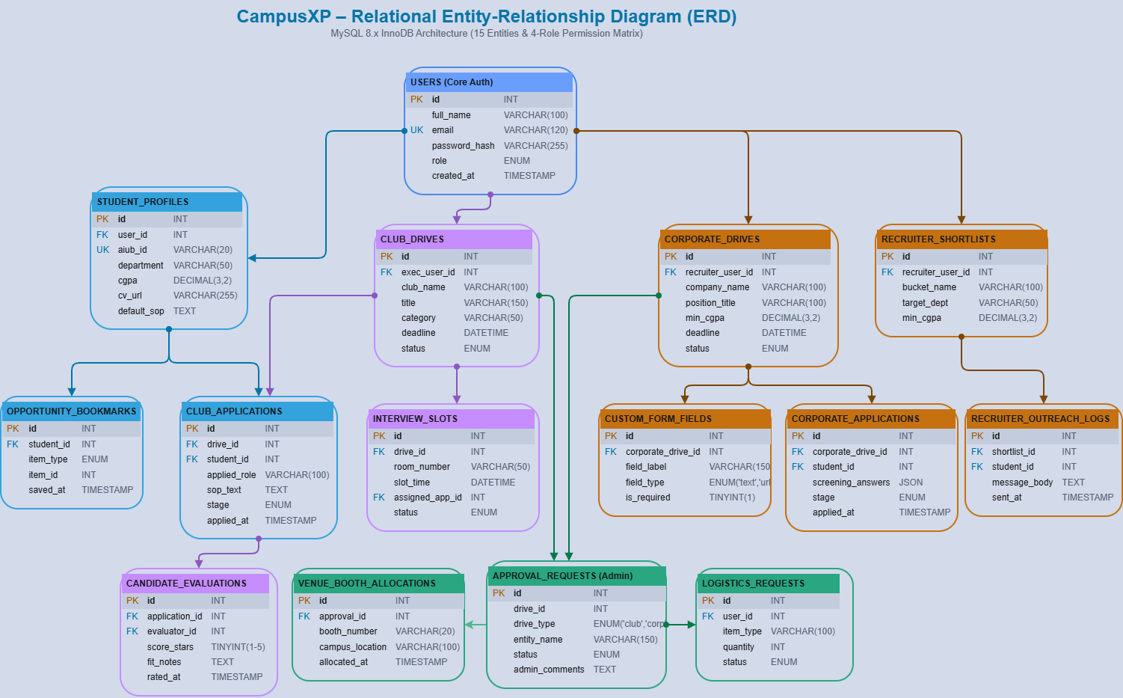
Figure 1: CampusXP Relational Entity-Relationship Diagram (14 Core Tables & 4-Role Architecture)

3.2 Relational Entity Dictionary
Table Name | Role Scope | Primary Key | Foreign Keys | Operational Function
users | Core Auth | id | None | User authentication accounts, roles, bcrypt password hashes
student_profiles | Student | id | user_id -> users.id | Locked AIUB student ID, department, CGPA, resume URL, default SOP
opportunity_bookmarks | Student | id | student_id -> student_profiles.id | Pinned campus drives and events for quick student access
club_applications | Student / Exec | id | drive_id, student_id | Application submissions, auto-filled SOP, and 5-stage Kanban status
club_drives | Club Exec | id | exec_user_id -> users.id | Club recruitment drives, category tags, deadlines, and locations
interview_slots | Club Exec | id | drive_id, assigned_app_id | 15-minute venue interview timeslots with campus room allocations
candidate_evaluations | Club Exec | id | application_id, evaluator_id | Star ratings (1-5), departmental fit remarks, and scoring logs
corporate_drives | Recruiter | id | recruiter_user_id -> users.id | Corporate job circulars, position titles, and CGPA thresholds
custom_form_fields | Recruiter | id | corporate_drive_id | Dynamic screening question schemas (URL/Portfolio/Text fields)
corporate_applications | Recruiter | id | corporate_drive_id, student_id | Submitted dynamic screening answers (JSON) and candidate stages
recruiter_shortlists | Recruiter | id | recruiter_user_id -> users.id | Filtered talent buckets based on department and minimum CGPA criteria
recruiter_outreach_logs | Recruiter | id | shortlist_id, student_id | Direct dashboard alerts and interview invitations dispatched to candidates
approval_requests | Admin / OSA | id | drive_id | Campaign moderation queue for approving/rejecting drives with feedback
venue_booth_allocations | Admin / OSA | id | approval_id | Physical booth reservations at AIUB plazas (Annex 1, Annex 3, MPH)
logistics_requests | Admin / OSA | id | user_id -> users.id | Physical equipment requisitions (sound systems, wireless mics, tables)
Use Case Diagram
4.1 Stakeholder Actors & System Boundary
The CampusXP system boundary encompasses all digital operations across the AIUB co-curricular lifecycle. Four distinct human actors interact with the system under strict Role-Based Access Control (RBAC):
- Student Actor: Undergraduate and graduate students seeking campus involvement, professional development, club sub-executive positions, and corporate internships.
- Club Executive Actor: Elected executive leaders of verified AIUB student organizations managing departmental and cultural recruitment campaigns.
- Corporate Recruiter Actor: External enterprise talent acquisition officers scouting top-performing AIUB engineering and business graduates.
- University Administrator (OSA Moderator) Actor: University administrative officers responsible for sanctioning official student events, maintaining campus decorum, and allocating physical resources.
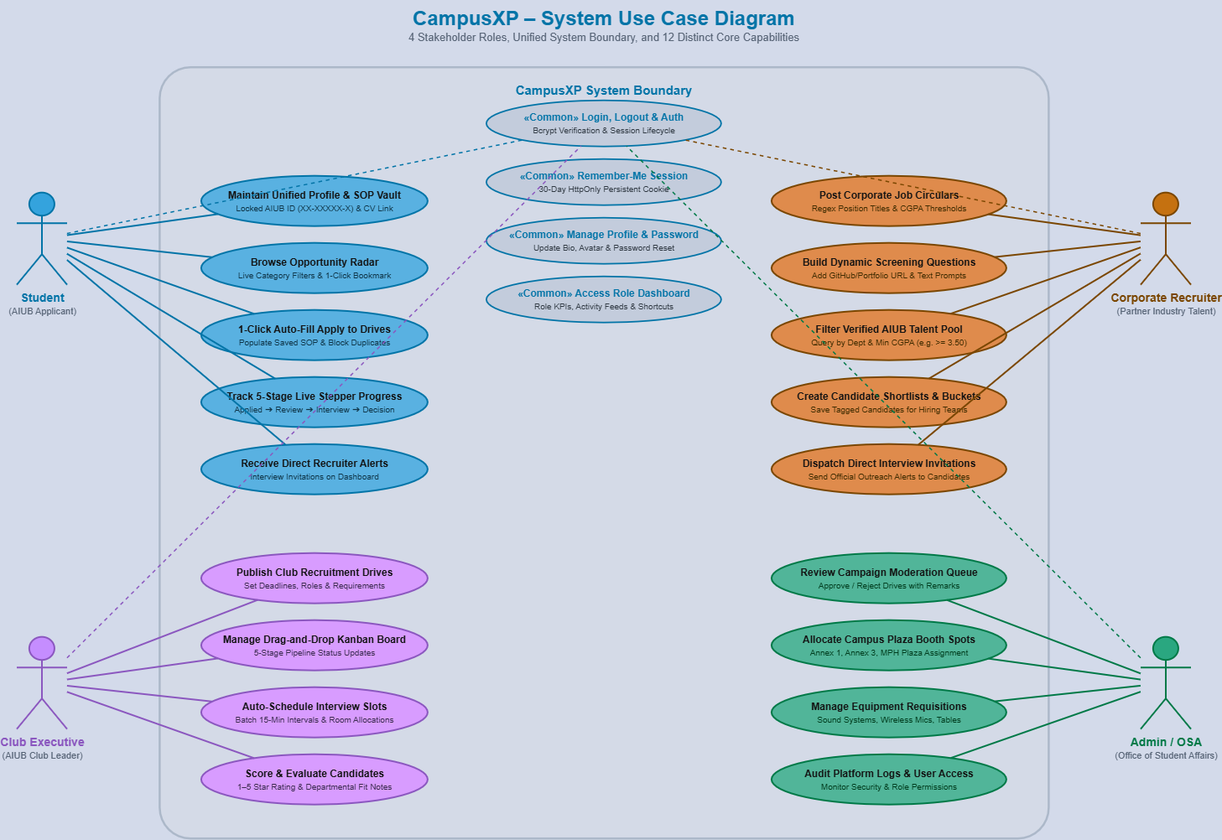
Figure 2: CampusXP Use Case Diagram (Actors, System Boundary & Non-Overlapping Capabilities)
4.2 Use Case Specification Matrix
Actor | Use Case Identifier | Trigger & Precondition | Expected System Behavior & Outcome
All Actors | UC-COM-01: Authenticate & Login | User submits credentials on login screen | Verifies bcrypt hash; creates session; sets 30-day "Remember Me" cookie
All Actors | UC-COM-02: Profile & Account Management | User accesses account settings | Allows viewing/editing profile bio; enforces password change verification
Student | UC-STU-01: Maintain Profile & SOP Vault | Student navigates to Profile Vault | Locks permanent AIUB ID; stores CV URL & default SOP for 1-click apply
Student | UC-STU-02: Explore Opportunity Radar | Student searches or filters active drives | Executes live category filtering; allows 1-click asynchronous bookmarking
Student | UC-STU-03: 1-Click Application Submission | Student clicks "Apply" on drive card | Auto-fills profile & SOP; verifies no duplicate application exists; logs submission
Student | UC-STU-04: Track 5-Stage Live Stepper | Student visits Applications tab | Displays visual pipeline (Applied -> Review -> Interview -> Selected) & alerts
Club Exec | UC-EXE-01: Publish Recruitment Drive | Executive fills campaign details | Submits drive for admin moderation; initializes applicant pipeline
Club Exec | UC-EXE-02: Manage Kanban Pipeline | Executive drags applicant to new stage | Updates candidate recruitment stage via drag-and-drop; updates student tracker
Club Exec | UC-EXE-03: Auto-Schedule Interview Slots | Executive specifies date, room & count | Batch generates 15-minute timeslots in Annex rooms without scheduling conflicts
Club Exec | UC-EXE-04: Candidate Evaluation & Scoring | Executive conducts interview session | Submits 1-5 star ratings and departmental fit notes to applicant record
Recruiter | UC-REC-01: Post Corporate Job Circular | Recruiter creates job opening | Validates position title format; publishes circular with CGPA requirements
Recruiter | UC-REC-02: Build Dynamic Screening Form | Recruiter adds custom prompts | Serializes custom URL/text validation fields into drive application schema
Recruiter | UC-REC-03: Filter Verified Talent Pool | Recruiter applies department/CGPA filters | Queries database for matching verified AIUB students; saves candidate shortlists
Recruiter | UC-REC-04: Dispatch Direct Outreach Alerts | Recruiter selects shortlisted candidates | Dispatches interview invitations and alerts directly to student dashboards
Admin (OSA) | UC-ADM-01: Review Moderation Queue | Admin reviews pending campaigns | Approves or rejects club/corporate drives with official review comments
Admin (OSA) | UC-ADM-02: Allocate Campus Plaza Booths | Admin inspects approved event requests | Assigns numbered physical booth spots at Annex 1, Annex 3, or MPH plazas
Admin (OSA) | UC-ADM-03: Manage Logistics Requisitions | Admin processes equipment requests | Tracks physical inventory of sound systems, wireless microphones, and tables
UI (Figma/Sketch)
5.1 User Interface Design Philosophy & Visual Tokens
CampusXP is styled using a modern Vanilla CSS3 Glassmorphism design system engineered specifically for high visual appeal and intuitive operation. The design architecture utilizes curated CSS tokens:
- Glassmorphism Design Tokens: Semi-transparent card backdrops (rgba(15, 23, 42, 0.75)), subtle ambient borders (rgba(255, 255, 255, 0.12)), and multidimensional drop shadows (0 12px 32px rgba(0,0,0,0.45)).
- Curated Role Color Hierarchy: Student Portal (Vibrant Sky Blue #38BDF8), Club Executive (Deep Purple #C084FC), Corporate Recruiter (Warm Amber #FBBF24), and Admin / OSA (Emerald Green #34D399).
- Modern Typography: Google Fonts pairing featuring Plus Jakarta Sans for structural brand headers and Inter for crisp, accessible UI elements and data tables.
- Interactive Micro-Animations: Smooth CSS transitions, active tab indicators, hover state elevations, and toast notifications provide instant visual feedback for every user interaction.
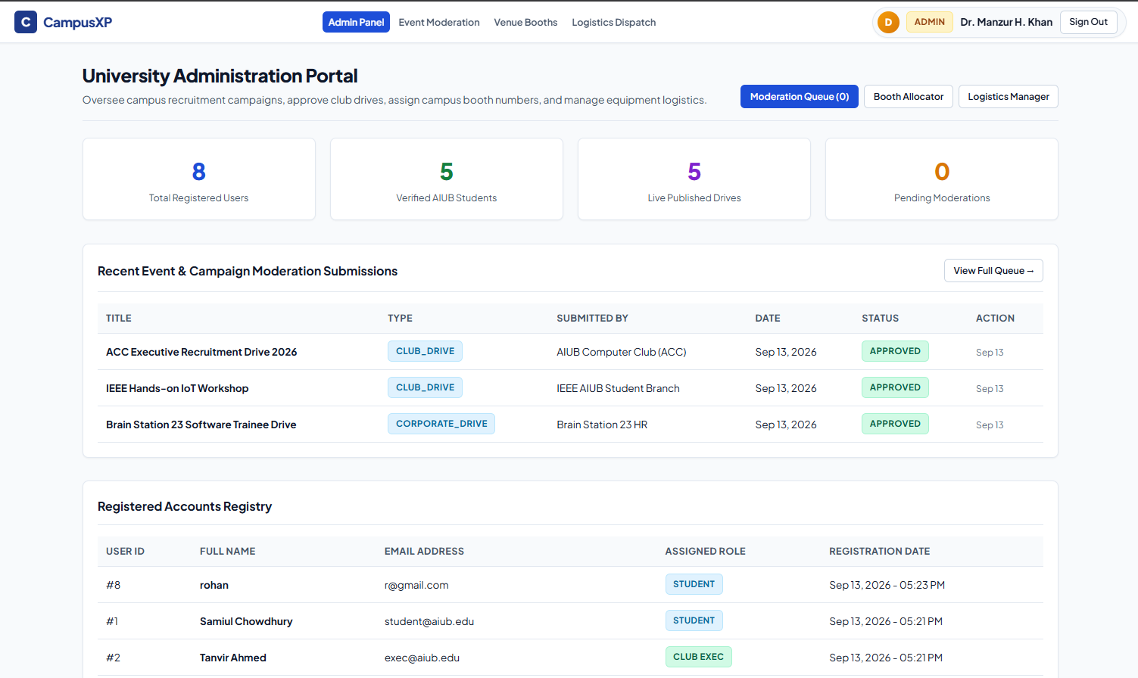
Figure 3: CampusXP Tentative User Interface Prototype Architecture Admin
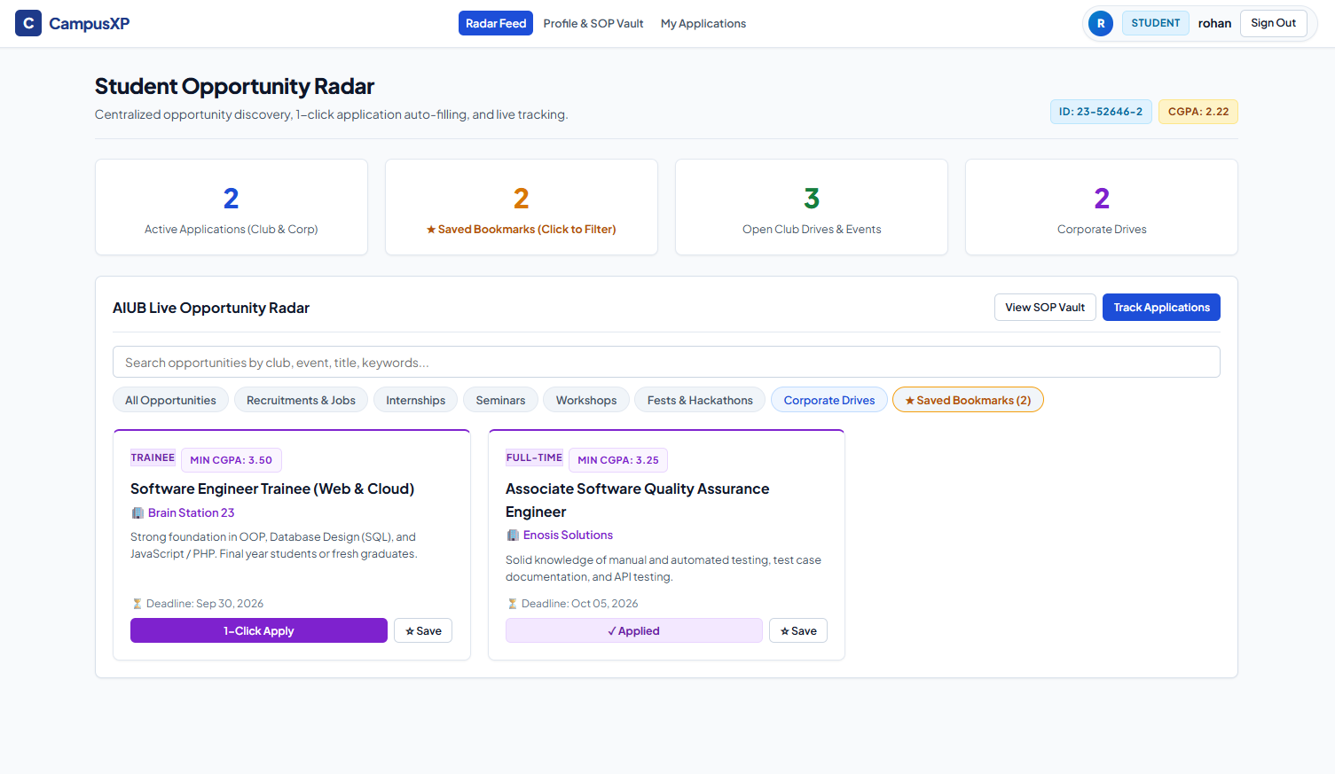
Figure 4: CampusXP Tentative User Interface Prototype Architecture Student

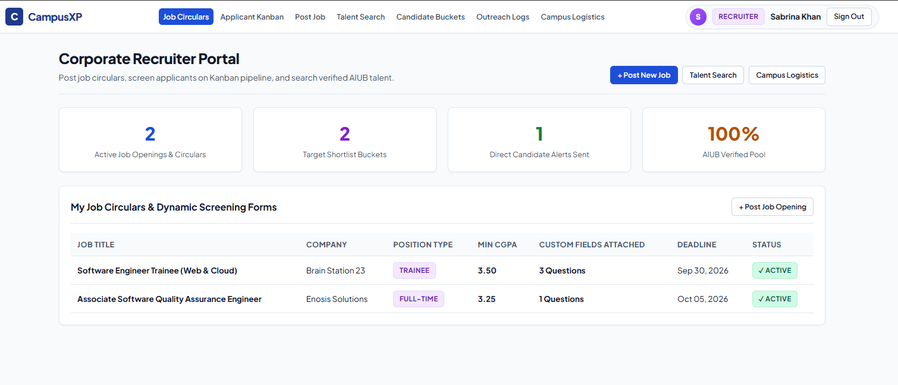
Figure 5: CampusXP Tentative User Interface Prototype Architecture Corporate Recruter
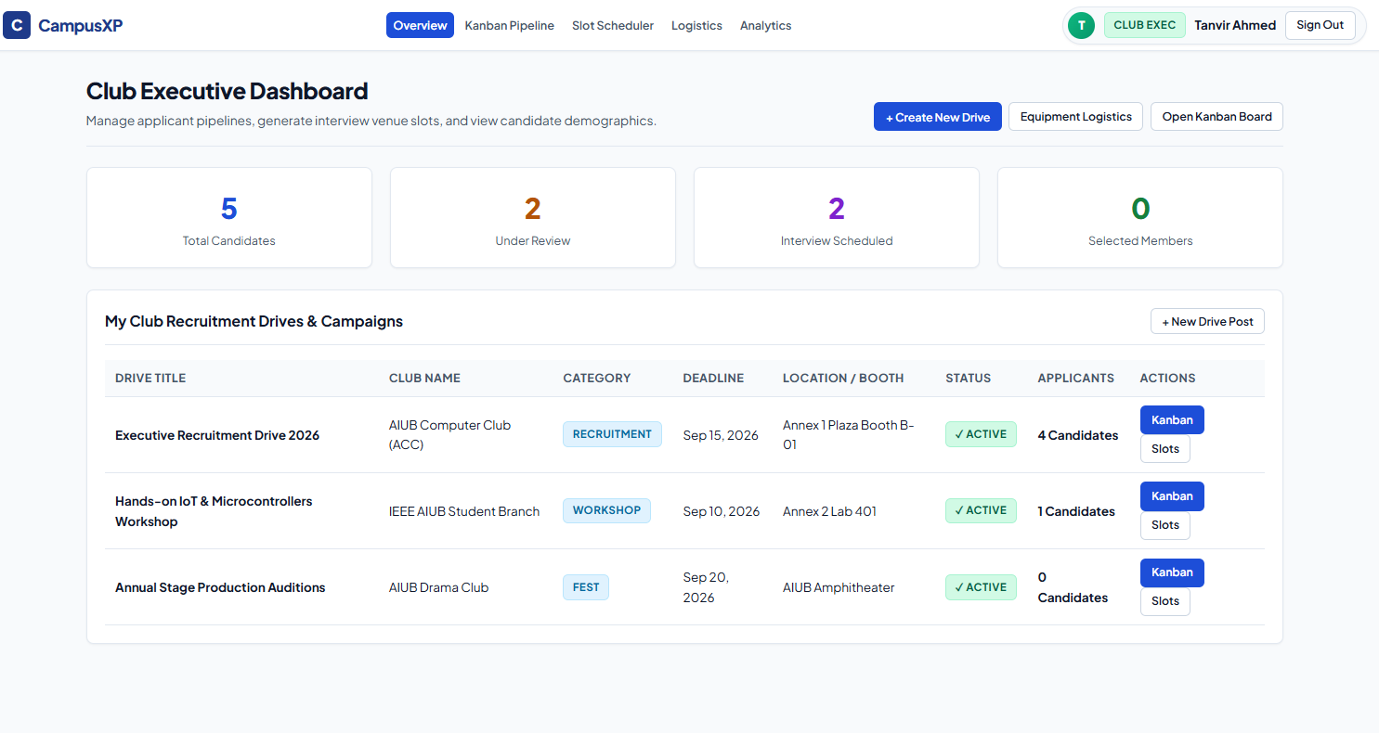
Figure 6: CampusXP Tentative User Interface Prototype Architecture Executive
5.2 Portal Layout & Component Breakdown
The system design incorporates four dedicated, responsive interface views:
- Student Portal (Opportunity Radar & Vault): Features a split-screen dashboard displaying the Unified Profile & SOP Vault on the left (featuring locked permanent AIUB ID 23-52631-2, CGPA, and resume drive links) and the Live Application Stepper on the right. Below, the Opportunity Radar presents searchable, filterable cards with 1-click apply triggers and AJAX bookmark toggles.
- Club Executive Portal (Kanban Pipeline & Scheduler): Provides a 5-column drag-and-drop Kanban recruitment pipeline (Applied, Under Review, Interview Scheduled, Selected, Rejected). Executives drag candidate cards to instantly update recruitment stages in the database. A dedicated Interview Slot Scheduler batch-generates 15-minute interview sessions with room assignments.
- Corporate Recruiter Portal (Form Builder & Talent Search): Equipped with a Dynamic Screening Question Builder where recruiters add custom questions (URL portfolio validators, coding challenge links, essay fields). A multi-criteria Talent Search Filter allows corporate partners to query verified AIUB students by department and minimum CGPA (e.g., CGPA >= 3.50).
- Administrator / OSA Moderator Portal (Moderation & Logistics): Features the Campaign Moderation Queue where submitted club and corporate campaigns are approved or rejected with feedback. Integrated spatial booth allocators assign physical AIUB plaza locations (Booth B-04 at Annex 1), and the Logistics Manager tracks audio-visual equipment requisitions.
Types of Users: 1. Student 2. Club Executive 3. Corporate Recruiter 4. University Administrator (OSA Moderator)
Common Features (Available to All Users)
- Authentication
  - Login to the system with secure bcrypt password hashing and persistent 30-day "Remember Me" session cookies (HttpOnly).
  - Logout from the system with complete session destruction, security token clearance, and cookie invalidation.
  - Role-based public registration for Students, Club Executives, and Recruiters with client-side regex and server-side PHP validation (Admin pre-seeded for security).
- Account Management
  - Change or reset password with current password verification and strong complexity regex checking.
  - Manage personal account settings (view, edit biographical profile, update contact information, and upload avatar assets).
- Dashboard
  - Access a personalized dashboard after login displaying role-specific statistical KPI metrics, activity feeds, quick-action shortcuts, and notification banners.
Specific Features by User Type (12 Distinct Non-Overlapping Features)
- Features of User 1: Student
  - Feature 1: Unified Profile & SOP Vault with 1-Click Application:Permanent verified AIUB Student ID (XX-XXXXX-X format), CGPA, locked department, uploaded CV URL, and default Statement of Purpose (SOP) that automatically populates into club and corporate applications without re-typing. [Dashboard CRUD: Manage Profile Vault]
  - Feature 2: Live Opportunity Radar with Asynchronous AJAX Bookmarking:Searchable, filterable real-time directory of active club recruitment drives, technical workshops, seminars, and corporate circulars with instant 1-click asynchronous bookmarking. [Dashboard CRUD: Manage Bookmarks]
  - Feature 3: Real-Time 5-Stage Application Progress Stepper & Outreach Alert Tracker:Visual linear progress tracking (Applied -> Under Review -> Interview Scheduled -> Selected / Rejected) with duplicate submission prevention and direct dashboard interview invitations from recruiters. [Dashboard CRUD: Track & Manage Applications]
- Features of User 2: Club Executive
  - Feature 4: Interactive Drag-and-Drop Kanban Recruitment Pipeline:5-column candidate stage-management board supporting real-time drag-and-drop transitions across recruitment phases with instant database persistence and applicant count analytics. [Dashboard CRUD: Manage Drives & Stages]
  - Feature 5: Automated Venue Interview Slot Auto-Scheduler:Batch generation engine that creates 15-minute campus interview timeslots with campus room allocations (e.g. Annex 1 Labs), auto-assigning applicants and preventing schedule collisions. [Dashboard CRUD: Manage Timeslots]
  - Feature 6: Candidate Scoring & Structured Evaluation System:Rubric-based evaluation tool with 1-5 star ratings, departmental fit assessment notes, and comprehensive applicant appraisal history logs for executive decision-making. [Dashboard CRUD: Manage Evaluations]
- Features of User 3: Corporate Recruiter
  - Feature 7: Dynamic Custom Screening Form Builder for Corporate Circulars:Flexible question builder enabling recruiters to define custom application requirements, including GitHub/portfolio URL validators and technical text prompts with regex-validated position titles. [Dashboard CRUD: Manage Job Circulars & Schemas]
  - Feature 8: Multi-Criteria Talent Search & Shortlist Buckets:Real-time candidate filtering engine allowing recruiters to query verified AIUB students by department and minimum CGPA threshold (e.g., CGPA >= 3.50) with saved candidate shortlist buckets. [Dashboard CRUD: Manage Talent Shortlists]
  - Feature 9: Direct Candidate Outreach & Interview Dispatching:Direct communication system allowing recruiters to dispatch official interview invitations and alerts directly to shortlisted students' dashboards with delivery and response tracking. [Dashboard CRUD: Manage Outreach Logs]
- Features of User 4: University Administrator (OSA Moderator)
  - Feature 10: Campaign & Event Moderation Queue: Formal verification and review workflow to inspect, approve, or reject pending club recruitment campaigns and corporate job circulars with official feedback comments prior to public release. [Dashboard CRUD: Manage Moderation Requests]
  - Feature 11: Campus Venue & Physical Booth Spot Allocator: Interactive spatial booth management assigning physical AIUB campus locations such as Annex 1 Plaza, Annex 3, or Multipurpose Hall to approved club and corporate drives to eliminate spatial collisions. [Dashboard CRUD: Manage Booth Allocations]
  - Feature 12: Logistics & Physical Equipment Requisition Dispatch Manager:Inventory requisition system managing physical campus resources including sound systems, wireless microphones, projectors, and registration tables for sanctioned drives. [Dashboard CRUD: Manage Logistics Requisitions]

